


Solution Document
Client | : Greystar
Department | : SSMAP
Process | : AP
Activity | : Invoice Processing NL
Project Manager | : Sachin Khattar
Productivity | : 0.12
Tech-Stack | : RPA

Contents
Document Control 4
Project Overview 4
Objectives 4
Scope 4
Stakeholders 4
As-Is Process 4
Description 4
Flowchart 4
Pain Points 4
To-Be Process 4
Description 4
Flowchart 4
Expected Benefits 4
Requirements 5
Functional Requirements 5
Non-Functional Requirements 5
Business Rules 5
Systems Involved 5
Current Systems 5
Future Systems 5
Integration Points 5
Process Steps 5
High-Level Steps 5
Keystroke-Level Steps 5
Roles and Responsibilities 5
RACI Matrix 5
Risks and Mitigations 5
Identified Risks 5
Mitigation Strategies 5
Acceptance Criteria 6
Success Measures 6
Key Performance Indicators (KPIs) 6
Handover Checklist 6
Appendices 6
Glossary 6
References 6
Supporting Documents 6

Solution Document
  - Document aims for Capturing As-Is and To-Be Processes, Requirements, and Project Essentials

Document Control
Version | Author | Date | Approvals
1 | Mohit Narula / Sachin Khattar / Bhavin Dave | 20-Apr | Praveen Jha / Sunanda Sarkar

Project Overview

Objectives

Automation of invoice processing through RPA implementation for NL residential properties, limited to 28 existing vendors

Scope
Below activities will be in the current scope
- Performing the OCR of the invoice
- Auto Indexing on Yardi
- Auto Attach of invoice copy on Yardi
- Uploading invoice to Invoice Register.
- Phase 1 limited to 28 existing vendors for NL residential entities only

Out of scope
- Sending the invoice to next level for invoice approval.
- Posting Invoice to Ledger.

Stakeholders
- Nisha Ram
- Paul Salonia
- Bjorn Holder
- Shantoshni Govender
Details of 28 vendors and their property list in scope of this project

As-Is Process

Description

Invoices are received through a shared mailbox.

The QX team manually reviews emails to identify invoice-related requests and moves relevant emails to a designated folder.

Invoice details are manually reviewed and validated, including billing information, historical bookings, and vendor details in Yardi.

Invoice descriptions in Dutch are manually translated into English using Google Translate.

Validated invoices are manually attached in Yardi, and invoice details are manually entered into Yardi as per the mandatory checklist (entity, vendor, bank details, dates, payment method, PO, etc.).

Any missing information or discrepancies are clarified with site teams via email or calls.

Upon completion, invoices are manually moved to the next workflow queue for further processing.

Flowchart
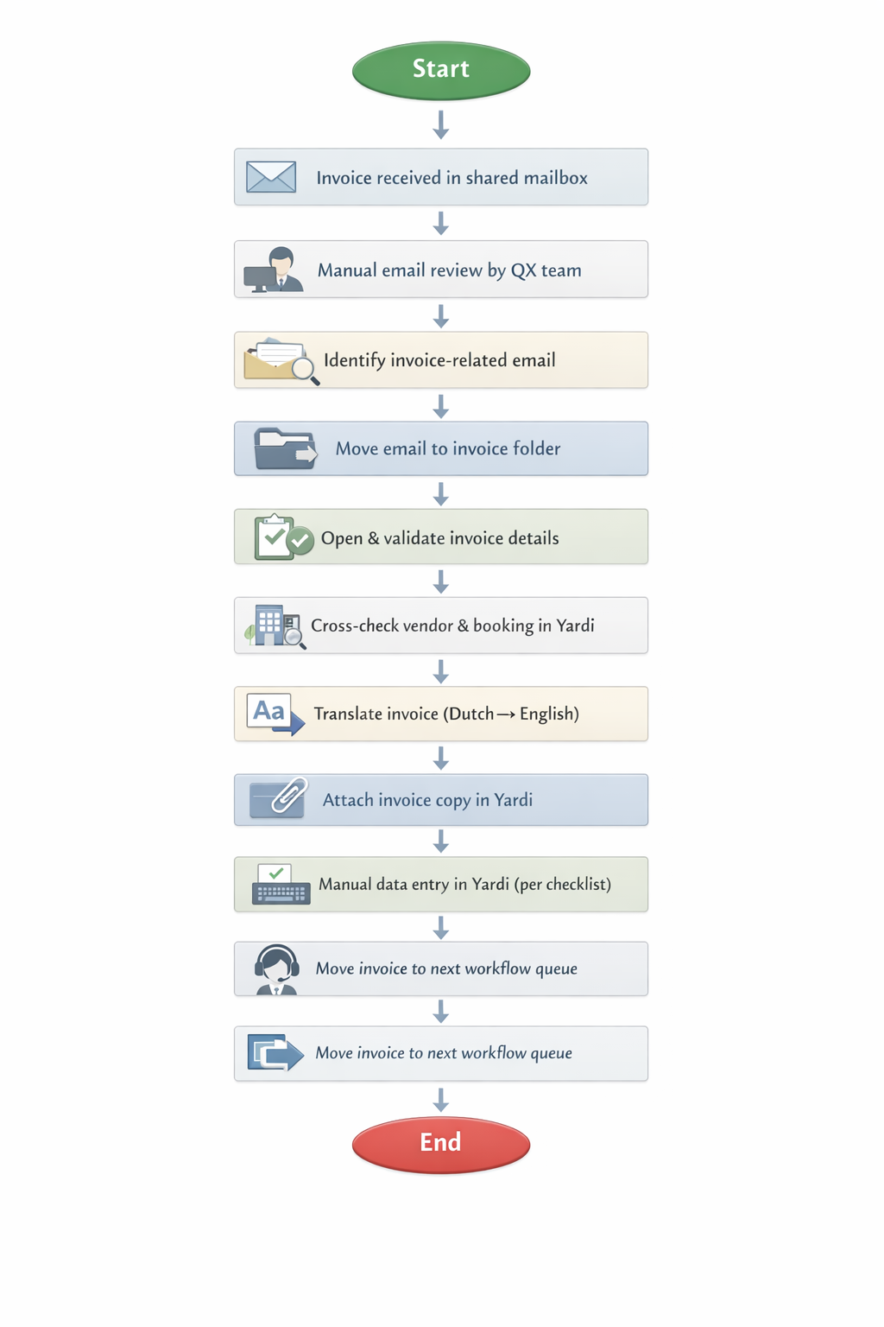

Pain Points
Area | Pain Point
Email Handling | Manual review of every email is time-consuming and error-prone
Invoice Identification | No structured separation of invoice vs non-invoice emails
Language Dependency | Manual translation using Google Translate increases processing time
Data Entry | Repetitive manual entry despite standardized fields
Operational Dependency | Frequent follow-ups with site teams slow overall turnaround
Control & Visibility | No upfront validation leading to rework later in the process
Productivity | One email may contain multiple invoices, increasing handling complexity

To-Be Process

Description
Proposed solution is a web-based invoice processing system that fetches invoices from a designated folder path via a scheduler (running every 15 minutes) or allows users to upload invoices. It performs OCR extraction, Dutch-to-English translation, and validation against master data and expense distribution reports. Valid invoices move to a Ready-to-Post queue, while exceptions are routed for review. The system generates ETL files and supports BOT-driven Yardi posting.
- Step 1: Invoice Location
  - Mailer desk/OPS team will save invoice files to:
    - Folder path
      - G:\QX\05. NL AP\Bot run\Input
        - System scheduler runs every 15 minutes to:
        - Scan the Input folder
        - Fetch newly added invoices
        - Register them for processing
    - Manual Upload
      - Users can directly upload invoices via UI
      - Uploaded invoices:
        - Immediately queued for OCR processing
        - Validate data and move invoices to Processed, Unprocessed or Duplicate folder
      - This bypasses dependency on folder sync delays
- Step 2: OCR Translation & Data Extraction
  - OCR Processing
    - Extract:
      - Invoice Number
      - Vendor name
      - Amount (Net + VAT)
      - Invoice Date
      - Invoice Due Date
      - Description
      - Property / Asset
    - Language Translation
      - Translate to English using AI engine
- Step 3: Data Validation & Enrichment
  - Validation against master data
    - Vendor master (vendor)
    - Property master (site name)
    - Expense distribution report (GL code)
  - GL Code Determination
    - Vendor + Property + Description
    - Historical mapping logic from Expense Distribution Report
    - AI semantic matching
  - Validation Outcome
    - If Valid
      - Process invoice with status Ready to Post
    - If Invalid (not found/incomplete)
      - Mark for Review
- Step 4: File Handling and Status Assignment
  - Valid Invoices
    - Rename invoice file using the Invoice Number
    - Move file from Input Folder → Processed Folder
    - Update status in UI to Ready to Post
  - Invalid Invoices
    - Move file from Input Folder → Unprocessed Folder
    - Update status in UI to Review
  - Duplicate Invoices
    - An invoice will be marked as Duplicate if all the following fields match an existing record:00
      - Vendor Name
      - Invoice Number
      - Invoice Date
      - Invoice Amount
      - Duplicate invoices will:
        - Be listed under Duplicate Queue
        - Be moved from Input Folder → Duplicate Folder
        - Be excluded from further processing
    - Users will not be able to change status for Duplicate invoices or process further from BOT.
- Step 5 Review & Correction (Web Application)
  - Review Listing/Queue
    - Users can review invoices in Review
  - Review Detail
    - Users can update invoices one by one
      - GL Code
      - Vendor/Property
      - VAT
      - Missing Fields
      - All relevant ETL dynamic fields (excluding static/default fields)
    - Move to Ready to Post
      - User can update corrections and change Invoice status to Ready to Post
    - Move Files to Processed folder
      - User need to manually move this Invoices from Unprocessed folder to Processed folder
  - Duplicate Listing/Queue
    - Users can view invoices in Duplicate and system move Invoice copies from Input to Duplicate folder
- Step 6: Ready to Post and ETL Generation
  - Invoice Selection
    - User selects Single/Multiple/All Invoices in Ready to Post section
  - Post Action
    - User click on Post Button
  - ETL File Generation
    - System generates ETL file (Yardi format) and saves to Output folder
  - Status update
    - Invoices moved to Posted section from Ready to Post with status set as ‘Posting in Progress’
- Step 7 Yardi Connector and BOT Execution
  - User triggers
    - Users triggers Yardi connector BOT
  - BOT Processing
    - BOT performs
    - Fetch ETL from Output folder
    - Fetch invoice copies from Processed folder
    - Upload into Yardi:
      - Invoice data (via ETL)
      - Invoice attachments
- Step 8 Posting Outcome Handling
  - Success Scenario
    - Posted Status
      - BOT completes upload successfully and status updates to Posted status
  - Retry Scenario
    - If BOT Fails due to any issue (technical/connectivity issue)
      - User needs to re-runs Yardi Connector
        - If successful, status changed to Posted from Posting in progress and move Invoices from Processed folder to Posted folder
        - If fails, status changed to Fail and move Invoices form Processed folder to Not Posted folder

Only exception invoices will require manual intervention; standard invoices will be processed in a touchless manner.

Pre-requisites
- Shared drive folder G:\QX\05. NL AP\Bot run\Input must be fully accessible and synchronized in near real-time (without 15–45-minute delays) to ensure timely availability of invoice files for OCR processing, validation, upload, and downstream automation.
- OPS/BTS team must review invoice emails and save all relevant invoice attachments in the designated Input folder to trigger the solution.
- The OPS team must regularly save and maintain the latest Expense Distribution Report in the following location: G:\QX\05. NL AP\Bot run\Expense Distribution Report
- The OPS team must manage and keep all required master data files up to date. Outdated or missing data may result in incorrect processing or failure to capture required information.
- Users shall not perform any activities within the system while the Yardi Connector is running. Yardi Connector will not resume processing from the point of interruption.
- In the event of failure, Yardi Connector shall always restart the execution from the beginning of the process.
- Invoices placed in the Unprocessed Folder shall require manual renaming by users, where applicable, before they are reprocessed or moved to the Processed folder.
- If invoice files are moved, deleted, or misplaced from their respective folders (Input, Processed, Unprocessed, Duplicate, etc.), users shall be responsible for manually relocating the files back to the correct folders to ensure proper system processing.

Flowchart
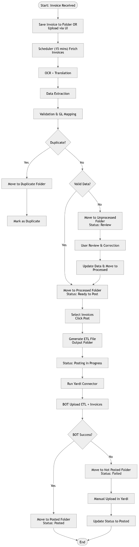

Expected Benefits
- Significant reduction in manual effort through automated routing, data capture, and RPA-led posting in Yardi.
- Faster invoice processing cycle time by eliminating manual email reviews, manual data entry, and repeated validations.
- Improved data accuracy and consistency due to ETL-based validation and standardized field population via RPA.
- Reduced dependency on manual translations by system-assisted Dutch-to-English conversion before processing.
- Lower rework and exception handling as invoices are validated upfront in the ETL layer before posting.
- Enhanced control and auditability with structured ETL approval and automated posting logs in Yardi.
- Better scalability to handle invoice volume increases without a proportional increase in headcount.
- Improved turnaround time for downstream workflows, enabling faster approvals and timely payments.
- Reduced operational risk by minimizing manual touchpoints, email-based handling, and dependency on individual processors.

Requirements

Functional Requirements
- [Specify system or process functions necessary for the to-be state.]

Non-Functional Requirements
- [Document performance, security, usability, or compliance needs.]

Business Rules
- Property code is selected by referring to the master tracker, based on the property name mentioned on the invoice.
- Payee code is determined based on the vendor’s name stated on the invoice copy.
- Offset account is defaulted in Yardi and may be cross-verified against the offset account reference sheet.
- Invoice date, due date, and invoice amount are captured as per the invoice copy.
- If the due date is not mentioned, it is set to 30 days from the invoice date.
- For internal vendors, the due date is the same as the invoice date. Internal vendor name starts with “Greystar Netherlands” in Yardi.
- GL code is derived from the vendor history available in the Yardi payee ledger currently and in to be it will be derived from expense distribution report.
- Notes are populated based on details mentioned in the invoice copy and historical payee ledger information.
- From and To dates are captured as per the invoice copy; if not provided, both dates default to the invoice date.
- Expense type is set as “Expense (Opex)”, and Display type is set as “NLVatApplicablePayable”.
- Transaction type is selected based on payee ledger history or the transaction type reference file, and VAT rate is captured as per the invoice (0%, 9%, or 21%).
- VAT tax amount is recorded as specified on the invoice copy.
- For vendor Eteck Incasso B.V., the unit number mentioned on the invoice is used as a reference for property code identification.

Systems Involved

Current Systems
- Yardi, Shared point, Excel

Future Systems
- [List systems to be used or implemented in the to-be process.]

Integration Points
- [Describe interfaces and data exchanges between systems.]

Roles and Responsibilities

RACI Matrix
Sr. | Page | Ownership
1 | Title Page | BTS
2 | Document Control | BTS
3 | Project Overview | BTS
4 | As-Is Process | BTS/Ops
5 | To-Be Process | Software
6 | Requirements | BTS/Ops
7 | Systems Involved | BTS/Ops/Software
8 | Process Steps | BTS/Ops
9 | Roles & Responsibilities | BTS/Ops
10 | Risks & Mitigation | BTS/Ops/Software
11 | Acceptance Criteria | BTS/Ops
12 | Handover Checklist | BTS/Ops
13 | Appendices | BTS/Ops/Software

FTE Efficiency

Risks and Mitigations

Identified Risks
- [List potential risks to project success.]

Mitigation Strategies
- [Describe measures to address or reduce each risk.]

Acceptance Criteria

Success Measures
- [Define what constitutes successful completion of the project or process.]

Key Performance Indicators (KPIs)
- [List quantifiable metrics to monitor progress and outcomes.]

Handover Checklist
- All process documentation completed and reviewed
- Access to required systems and environments provided
- Contact list for key stakeholders and support teams shared
- Supporting artifacts (e.g., diagrams, data samples, test cases) attached
- Open issues and outstanding actions documented

Appendices

Glossary
- [Define terms and acronyms used in this document.]

References
- [Cite relevant documents, standards, or resources.]

Supporting Documents
- [List or attach supplementary materials as needed.]

